## **Online Food Ordering**

HUNTER, an Online food ordering webapp, built with ASP.net MVC technology in which one can order various foods through the use of internet, just by sitting at home or any place. And the order is delivered to the told location.

The Web App connects different restaurants with customers. The project contains an admin(manager) and the user side

**Admin**

All the management like editing site contents, updating food items, adding restaurants, and checking order status can be managed from the admin side. Through an admin panel. There can be many managers on the site.

**Customer**

For the user section, the user has to create an account and sign in or log in. The food comes with the cost as well. This project makes a convenient way for customers to buy/purchase food online, without having to go to the restaurant.

**The features of this system are the following:**

* order product online
* upload product design online
* add, edit, delete product

**Overview of the technology used**

**Front end:**

* HTML,
* CSS,
* JavaScript

**Back end:**

* Asp,net MVC with c#
* SQL server

**Class Diagram**

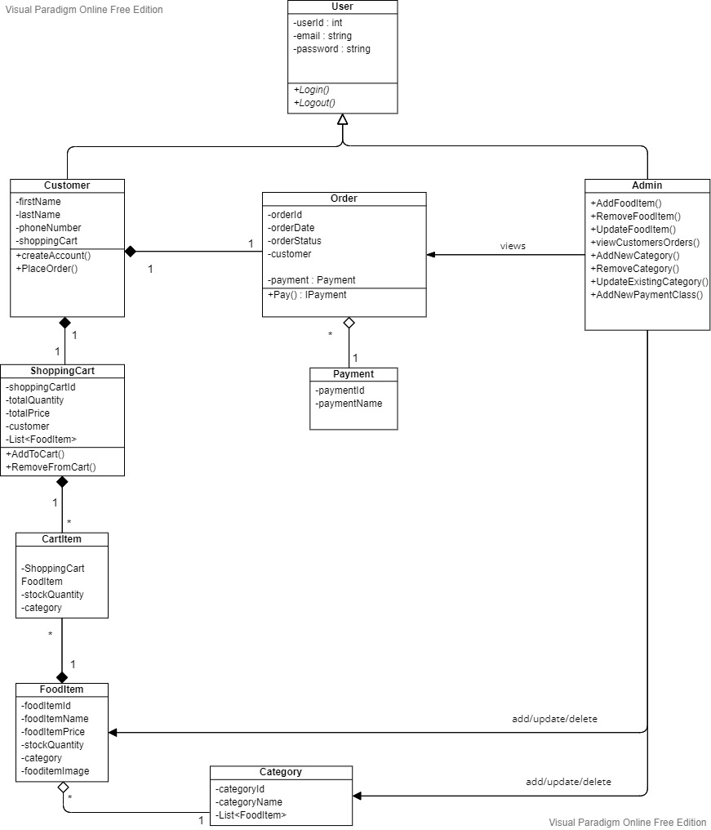

**ERD Diagram**

